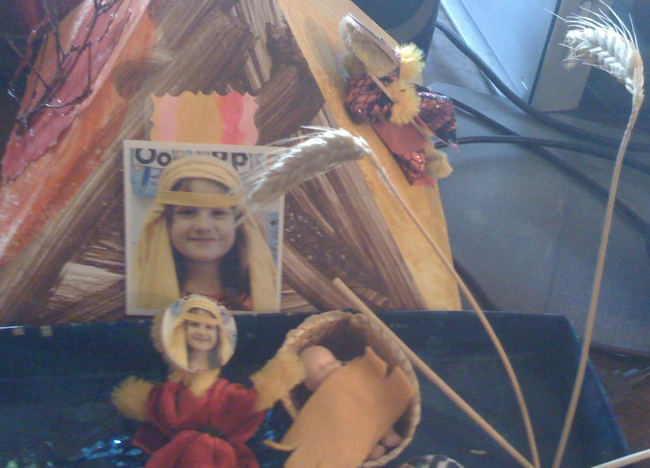

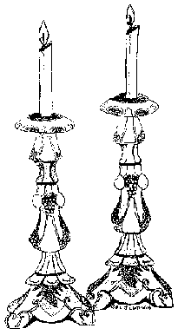
The order of the Seder:

- Light the Candles

Reader: With song and story and the symbols of the Seder, let us renew the memory of our past so that we might know what was freedom and what was slavery. Let the Pesach story continue to be a beacon for justice and freedom for all mankind.

- We are Jews

Reader: The lighting of the candle symbolizes replenishing life day after day, year after year. Lighting the fire brings back memories of times gone by, of trials and tribulations, of heartache and desire. The story of the Jews is the story of the years of wandering, what is called 'the Diaspora'. Since the Roman times, the Jews were forced to move from country to country - never having their own homeland.

Reader: Each year at Pesach we celebrate the story of the Jews’ fight for freedom from slavery in Egypt. We also use this time of year to remember ALL the fights that Jews have had to be part of to survive. Jews were not allowed to own land. Jews were not allowed to practice their own religion.

- We are also members of Humankind

Reader: And just as we have been abused, persecuted and prejudiced against – so are others suffering the same fate. So we use Pesech to remember and acknowledge the hardships others are forced to endure.

- Lomir alle in aynem

Reader: Many aspects of our Jewish culture have been lost. The traditions of our forefathers are being forgotten for Dora, Kim Possible and Hannah Montana. One of the most important parts of our culture is the language of our bubbie and zaddahs - Yiddish.
This Yiddish song welcomes us to Pesach.

Song: Lomir alleh in Aynem (Yiddish song to welcome Pesach)

"Lomir alleh in aynem, in aynem, in aynem
Dem Pesach m'kah-bel ponem zine (2)
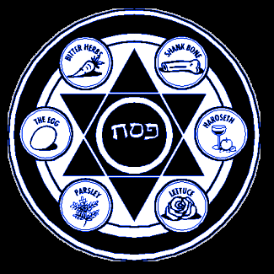
Lomir alleh in aynem (2)
Trinken a gleh-zeh-leh vine
Lomir alleh in aynem (2)
Trinken a gleh-zeh-leh vine

Lomir alleh in aynem, in aynem, in aynem
Dee guest m'kah-bel ponem zine (2)

Lomir alleh in aynem (2)
Trinken a gleh-zeh-leh vine
Lomir alleh in aynem (2)
Trinken a gleh-zeh-leh vine“

- 1st cup of wine

Reader: Throughout this Seder we will drink four cups of wine. Usually its just grape juice. Every young Jewish child gets drunk for the first time – during Pesech Seder.

Does anyone know what the symbolism of four cups of wine is?

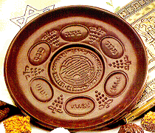
- The Seder plate (part 1)
"Whoever enlarges upon the story of the outgoing from Egypt, that man or woman merits praise."

Any kid can ask a question any time!

Wash your hands
Take the Egg and dip in into the salt water = tears of life
Greens (Karpas) (parsley) dip IT into the salt water = spring

Deliver us from Slavery

- Ain’t gonna study war no more
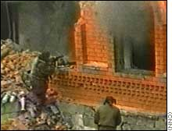
Group: I ain't Gonna Study War No More!
"I'm gonna lay down my sword and shield
Down by the riverside (3)
I'm gonna lay down my sword and shield
Down by the riverside
I ain’t gonna study war no more
I ain't gonna study war no more (3)
I ain't gonna study war no more" (3)

- Seder Plate (part 2)

Shankbone = Exodus, Rejoicing, God out reaching his hand to lead us from slavery
Matzah = in too much of a hurry that the bread didn’t have time to rise, 40 years of wandering
Maror = horseradish – bitterness of slavery personified
Charosis = apples, raisins, wine, nuts, honey – the mortar that glued the bricks together
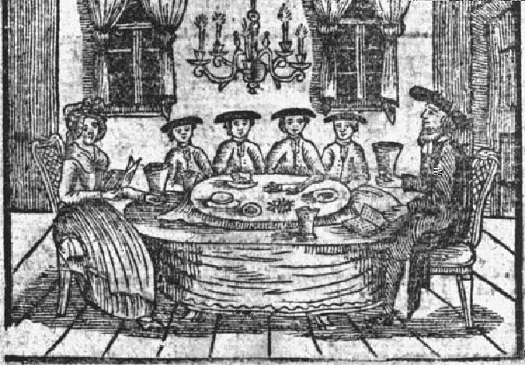

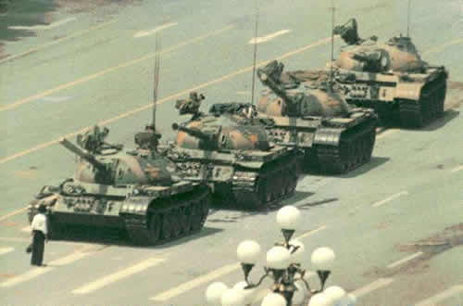
- Dee Gedanken sind frei
Group: Dee Gedanken Zind Frei
"Dee gedanken zind frei, My thoughts freely flower,
Dee gedanken zind frei, My thoughts give me power
No scholar can map them, No hunter can trap them
No man can deny,
Dee Gedanken zind frei!
So I think as I please, and this gives me pleasure.
My conscience decrees, This right I must treasure;
My thoughts will not cater To Duke or Dictator,
No man can deny
Dee Gedanken zind frei!
And if tyrants take me And throw me in prison,
My thoughts will burst free Like blossoms in season.
Foundations will crumble, The structure will tumble
And free men will cry:
Dee Gedanken zind frei!"

- Hide the Afikomen

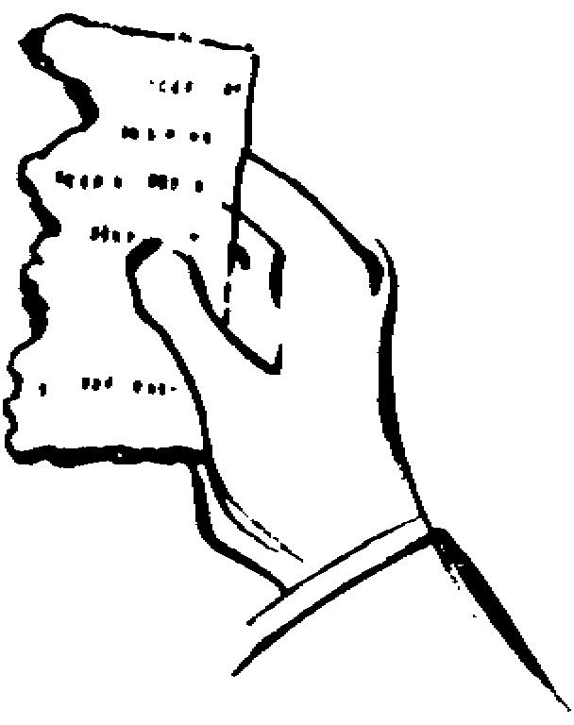
"Baruch Atah Adonai
Eloheinu melach ho-olam
ha-motzi lechem min ha-aretz"
"Baruch Atah Adonai
Eloheinu melach ho-olam
asher kidi-shanu b'mitzvo-tav 'v'tzivanu ahilat matzah"

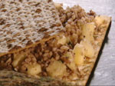
- Hillel sandwich

History of Sandwiches
http://whatscookingamerica.net/History/SandwichHistory.htm

1st Century B.C. - The first recorded sandwich was by the famous rabbi, Hillel the Elder, who lived during the 1st century B.C. He started the Passover custom of sandwiching a mixture of chopped nuts, apples, spices, and wine between two matzohs to eat with bitter herbs. The filling between the matzohs served as a reminder of the suffering of the Jews before their deliverance from Egypt and represented the mortar used by the Jews in their forced labor of constructing Egyptian buildings. Because he was the first known person to do this, and because of his influence and stature in Palestinian Judaism, this practice was added to the Seder and the Hillel Sandwich was named after him.

Charosis, Maror, Matzoh = Hillel sandwich – and this certainly proves the point – that you’re never too old to learn something new!

- History of…… (Korech – bond with our ancestors)

Reader: All who are hungry.....
Group: Let them come in and eat
Reader: All who are needy.....
Group: Let them come in and celebrate Pesach
Reader: Now we are in a world where men and women are still alien to each other....
Group: Next year may we be truly brothers and sisters to one another.
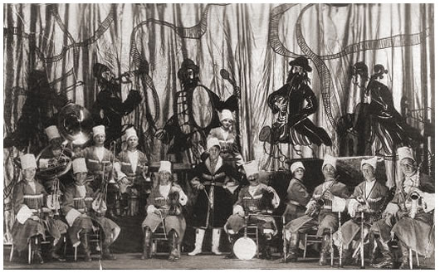
Reader: Now we are slaves to bigotry and prejudice....
Yiddish Jazz band
Zog nit Keymol

This song was smuggled out of the concentration camps in Spain during the Spanish Civil War. Spain was Hitler’s Beta test.
Group: Zog Nit Keymol
(Yiddish) "Zog nit keymol as doo geyst dem letsen veg,
Chotsch himlen blayne farshteln a bloyeh teg;
Vil koomen vet noch undzer oisgebenkte shaw;
S'vet a poik tawn oonzer trawt;
MIR ZEINEN DAW!"
(repeat entire paragraph twice)
(Hebrew) "Ana hamar heney dakee Ha-ach-ro-nai
Et or ha-yom who schtay roo Schmee ha ah-nah-nah
Zay yom nich saft-nu lo-ho ya-hah v'yah-voh
Ooo mits a-daney od yarem anachnu po"
(repeat entire paragraph twice)
(English) "Oh never say that you have reached the very end,
Tough leaden skies a bitter future may portend
Because the hour for which we yearned will yet arrive
And our marching steps will thunder,
We survive!"
(repeat entire paragraph twice)
"Not lead, but blood inscribed this very song we sing,
It's not a caroling of birds upon the wing.
But t'was a people midst the crushing fires of hell,
That sang this song and fought courageous till they fell."
(repeat entire paragraph twice)
"Partisanim, Heney Anachnu" (2) - fade out.....
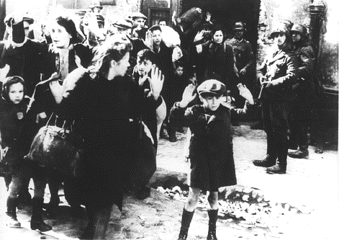

- Second glass of wine

"Ma nish-to-nah Ha-lei-lah Ha-zeh mi-kol ha lei los, mi-kol ha lei los"

Group: Why is this night different from all other nights?

Reader: For on all other nights we eat either bread or matzah, but on this night we eat only matzah. This is to remind us of the exodus from Egypt when our ancestors could only take unleavened bread.

"Ma nish-to-nah Ha-lei-lah Ha-zeh mi-kol ha lei los, mi-kol ha lei los

Sheb-a-col ha-lei-los, o-nu och-lin she-or ye-ro-kos

Ha-lei-lo ha-zeh, Ha-lei-lo ha-zeh, maror, maror "

Reader: For on all other nights we eat only vegetable, but tonight we eat maror. This is to remind us of the bitter life of slavery.

"Ma nish-to-nah Ha-lei-lah Ha-zeh mi-kol ha lei los, mi-kol ha lei los

Sheb-a-col ha-lei-los, ain o-nu mat-bi-lin a-fi-lu pa-am a-chas

Ha-lei-lo ha-zeh, Ha-lei-lo ha-zeh, shteh p'onim, shteh p'onim "

Reader: For on all other nights we do not dip our vegetables ever once; but tonight we dip them twice. While we dip the greens in salt water to remind us of the tears of slavery, we dip the bitter herbs in sweet charosis as a sign of hope - no matter how terrible slavery was, man and woman still have hopes for freedom.

"Ma nish-to-nah Ha-lei-lah Ha-zeh mi-kol ha lei los, mi-kol ha lei los

Sheb-a-col ha-lei-los, o-nu och-lin bain yosh-vin u-bain m'subin

Ha-lei-lo ha-zeh, Ha-lei-lo ha-zeh, ku-lo-nu m'subin, ku-lo-nu m'subin "

Reader: For on all other nights we eat sitting up straight, but tonight we eat reclining. This is to remind us that as free men and women we can recline, but we must remember that not all men and women are free today and we must help others achieve the freedom and prosperity we enjoy
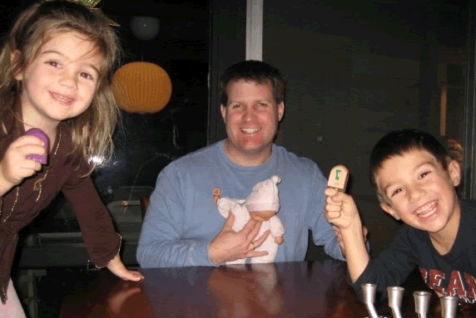
- Ballad of the Four sons:
The Ballad of the Four Sons
(to the tune of "Clementine")
Said the father to his children,
"At the seder you will dine,
You will eat your fill of matzoh,
You will drink four cups of wine."
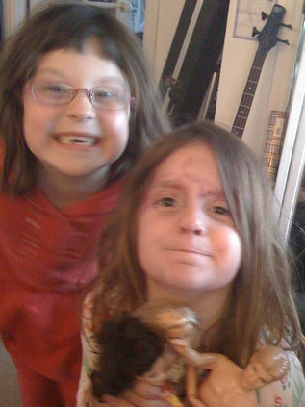
Now this father had no daughters,
But his sons they numbered four.
One was wise and one was wicked,
One was simple and a bore.
And the fourth was sweet and winsome,
he was young and he was small.
While his brothers asked the questions
he could scarcely speak at all.
Said the wise one to his father
"Would you please explain the laws?
Of the customs of the seder
Will you please explain the cause?"
And the father proudly answered,
"As our fathers ate in speed,
Ate the paschal lamb 'ere midnight
And from slavery were freed."
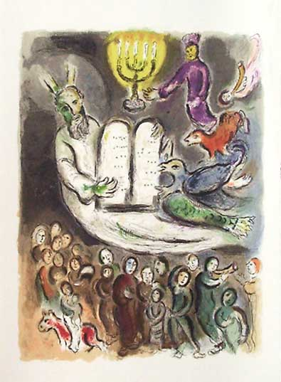
So we follow their example
And 'ere midnight must complete
All the seder and we should not
After 12 remain to eat.
Then did sneer the son so wicked
"What does all this mean to you?"
And the father's voice was bitter
As his grief and anger grew.
"If you yourself you don't consider
As son of Israel,
Then for you this has no meaning
You could be a slave as well."
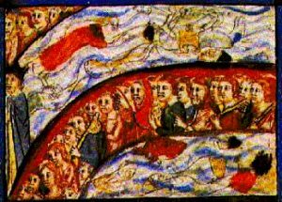
Then the simple son said simply
"What is this," and quietly
The good father told his offspring
"We were freed from slavery."
But the youngest son was silent
For he could not ask at all.
His bright eyes were bright with wonder
As his father told him all.
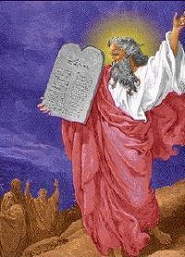
My dear children, heed the lesson
and remember evermore
What the father told his children
Told his sons that numbered four.
Sam, Athena, Lucy and Miriam: Tell the story of the Jews leaving Egypt.
- Four Questions:

#1.
Reader: The wise child asks: "What are the testimonies, laws and behaviors that we can learn?" - Deuteronomy 6:20

Reader: With him or her you discuss the nature of freedom and justice and the observations of Pesach. He or she shall begin to work out his or her own ideas as to the meaning of Pesach. With him or her you may write or live a new Haggadah from year to year.

Group: It is wise people who want to know the service, it is theirs to do.

#2.

Reader: The skeptical child asks "Of what use is this observance and service to you?" Exodus 12:26

Reader: It is because of what the Lord did for ME when I went forth from Egypt - 'for me' that is, and not 'for you'.... for had YOU been there, you would not have known redemption. To you, not him, because he takes himself out of the collective body, he denies the community of man. He has forgotten that freedom is everybody's business.

Group: The skeptical (wicked) one withdraws himself from anything beyond himself, and thus, from his own redemption.
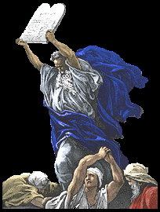
#3.

Reader: The simple child asks "What is this all about?" Exodus 13:14

Reader: With a mighty arm God freed us from Egypt, from the house of bondage. We tell the simple child that we are remembering that long ago in another country our families were forced to work as slaves. They rebelled and became free men and women. Now we are celebrating this freedom.

Group: To the person of open simplicity, give a straightforward answer, for "the Torah of God makes wise the simple." Psalm 19:7

#4.

Reader: To the child who is too young to ask questions, you should explain without waiting for him or her to ask. This is the story of how our ancestors left Egypt. In time, we will learn the true meaning of Pesach.

Reader: You shall tell your child on that day, saying "This is because of what the Lord did for me when I went free from Egypt" Exodus 13:8

- More on the story of the Jews leaving Egypt (in honor of Chuck Heston R.I.P.)

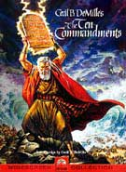
Let’s recollect and contemplate the irony of Charleton Heston. Here was a shiksa, gun toting red-blooded American who made his career playing Jews, Indians and good guys. Heston exemplified the imperialistic, chauvinistic, gun toting capitalistic notion of America. Yet he was most famous for Moses.

And isn’t that saying something about our country? We’re made up all sorts of wonderful people – but lots of bad people as well.

This is our first seder with Obama as our president. What greater symbolism do we have to celebrate – than our first black president?
17. Same sex marriages
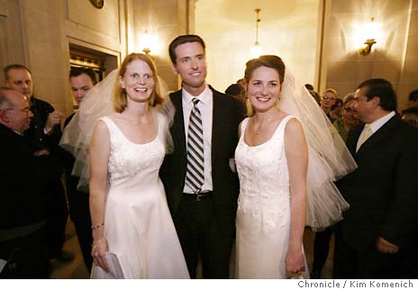
There’s another kind of revolution going on, and it’s happening here in our city of San Francisco.

People will be able to marry whomever they want – when they want. What a notion!

Our Mayor is fighting to make this happen, even if the fascists and religious nuts are trying to prevent this most basic of human rights.

That’s enough of a reason o elect him Governor – if you ask me!

Third cup of Wine

Group: (dip your finger in wine for each plague and put it onto a napkin or matzah.)

1. Dam, blood
2. Tzfardeyah, Frogs
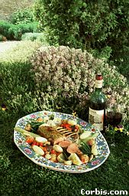
3. Kinim, Lice
4. Arov, Wild beasts
5. Dever, Blight
6. Sh'him, Boils
7. Barad, Hail
8. Arbeh, Locusts
9. Hosheh, Darkness
10. Makat B'horot, Slaying of the first born

18. Dayenu
Group: Dayenu
"I-lu ho-tzi, ho-tzi-ah-nu
Ho-tzi-ah-nu mi-mitz-ra-yim
Ho-tzi-ah-nu mi-mitz-ra-yim,
Dayenu:
Day-day ye-nu, Day-day ye-nu
Day-day ye-nu, Da-ye-nu
Da-ye-nu"
(repeat paragraph) (2)

19. Elijah’s Cup – the fourth cup of wine
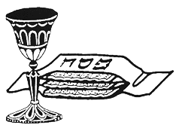
Group: May we beat their swords into plowshares and their spears into pruning hooks. May nation not lift up sword against nation, neither learn war no more. Then shall men be free from tyranny, violence and evil and united in brotherhood (and sisterhood.) Then will Jews everywhere celebrate their freedom, and all men and women will celebrate the universal festival of freedom and independence.

20. More Songs
Group: (while serving the soup) Zum Gali, Gali
"Zum Gali, Gali, Gali;
Zum Gali, Gali (2)
Hechalutz le'man avodah;
Avodah le'man hechalutz
Avodah le-man hechalutz;
Hechalutz le-man avodah"
(repeat in round)

Group: Eliyohu Hanovi
"Eliyohu hanovi,
Eliyohu Ha-tish-bi,
Eliyohu, Eliyohu, Eliyohu hagilodi.
Bimeheroh beyomenu, yovo elenu
Im Moshiah ben David,
Im Moshiah ben David.
Eliyohu hanovi, Eliyohu Ha-tish-bi,
Eliyohu, Eliyohu, Eliyohu hagilodi."

Group: Let my People Go
"When Israel was in Egypt land,
Let my people go.
Oppressed so hard they could not stand,
Let my people go
Go down, Moses - Way down in Egypt land
Tell old Pharoah, To let my people go
No more shall they in bondage toil,
Let my people go
They shall go forth with Egypt's spoil,
Let my people go
Go down, Moses - Way down in Egypt land
Tell old Pharoah,
To let my people go"

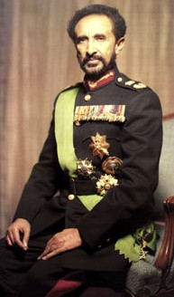
Other religious rituals:
1. Sing your children to sleep at night.

2. Jah Rasta Fari – ever living, ever fearful Rastaman Vibration

3. Fight for the open social web!

4. Hustling customers, keeping them happy and then having to fight to get paid!

Chorus: Chad Gadya
"That my father bought for only two zuzim: Chad Gadya, Chad Gadya
1. Then came the cat who ate the kid (chorus)
2. Then came the stick which beat the dog, that bit the cat, that ate the kid (chorus)
3. The came the fire that burnt the stick, which beat the dog, that bit the cat, which ate the kid (chorus)
4. Then came the water, that quenched the fire, that burnt the stick, that beat the dog, that bit the cat, which ate the kid (chorus)
5. Then came the ox, that drank the water, that quenched the fire, that brunt the stick, which beat the dog, that bit the cat, which ate the kid (chorus)
6. Then came the butcher, who slew the ox, that drank the water, that quenched the fire, that brunt the stick, which beat the dog, that bit the cat, which ate the kid (chorus) "


